**Name: Shivam Borse**

**Roll No: 19**

**Subject:SL AI ( LAB )**

**Branch: AI & DS**

-------------------------------------------------------------------------------------------------------------------

***Assignment 14***

**Aim:**

Mini Project: Implement any one of the following Expert System

• Information management

• Hospitals and medical facilities

• Help desks management

• Employee performance evaluation

• Stock market trading

• Airline scheduling and cargo schedules

**Code:**

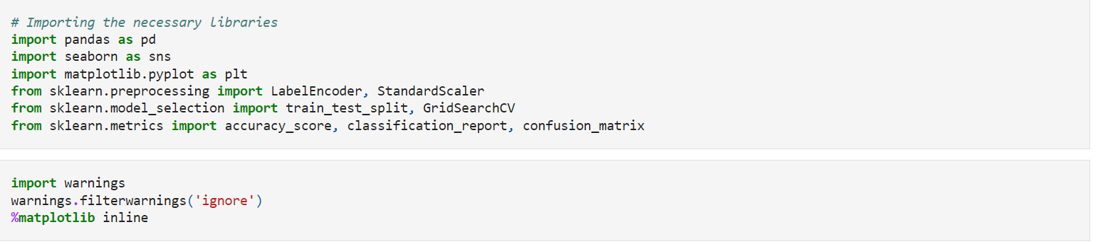



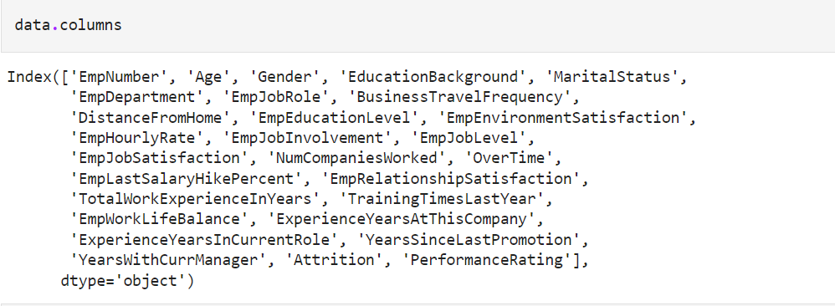

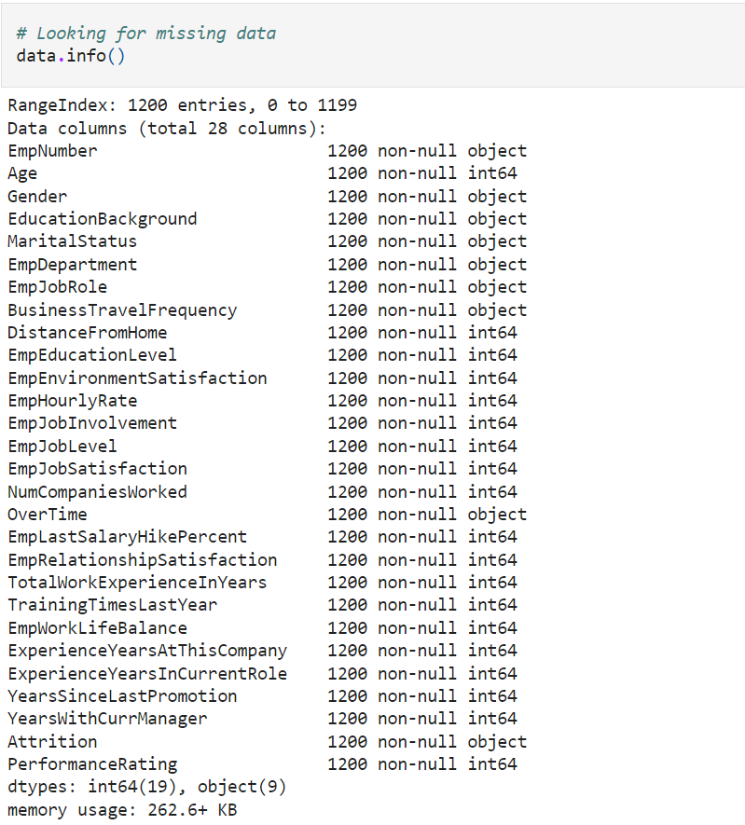

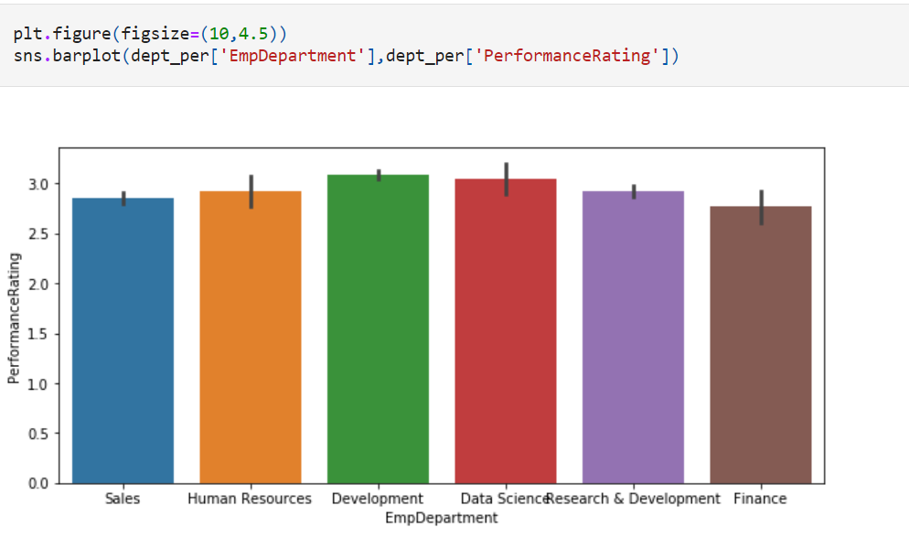

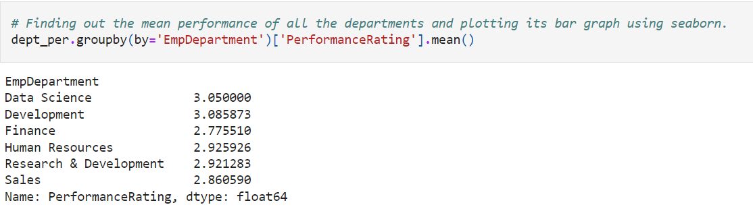

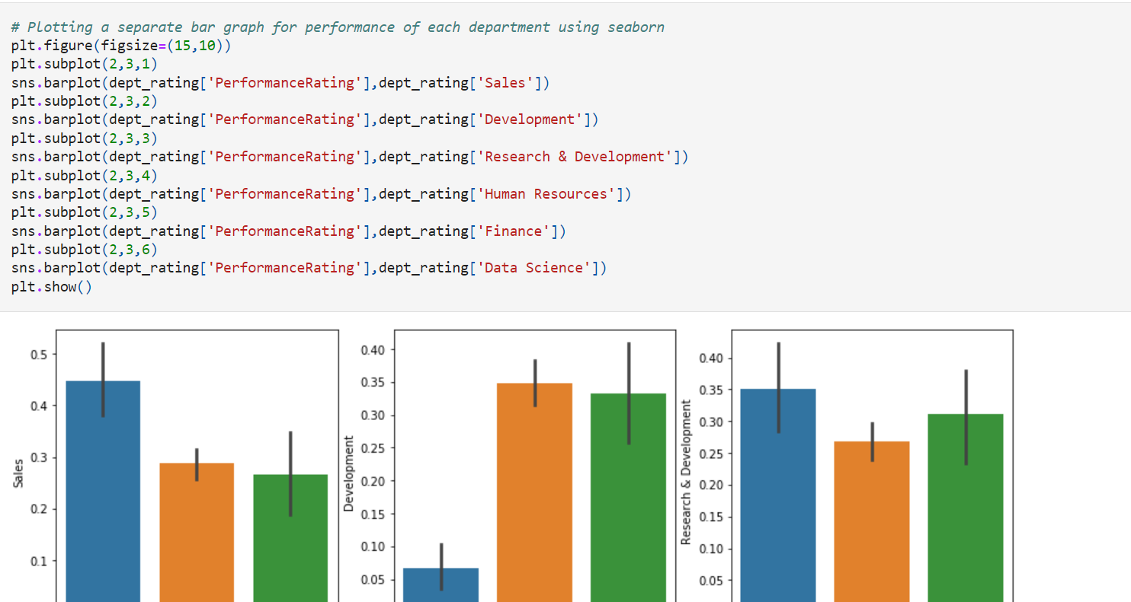

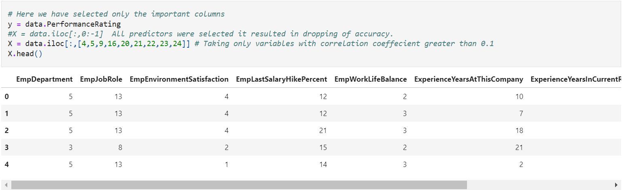

**Dataset:**

